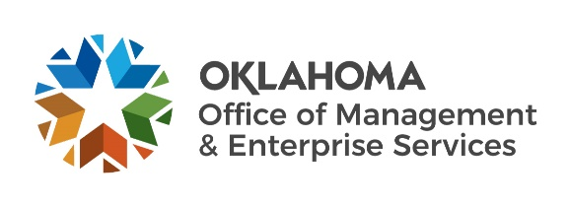
Mental Health Plan Coverages offered by the State of Oklahoma

Summary
- All health insurance options offered by the State of Oklahoma for employees include mental health and substance abuse coverage, including the diagnosis of Post-Traumatic Stress Disorder (PTSD). While each plan is unique in its product offering and limits, there remains consistent access to coverage across all available plans.
Coverage Options Available
- HealthChoice coverage details:
  - PTSD is a diagnosis and would be covered under our mental health benefits. HealthChoice covers services for outpatient visits, intensive outpatient, partial hospital and inpatient admissions.
  - There is no limit placed on these services. Like any mental health diagnosis, a member can utilize 20 outpatient visits per year without a prior authorization and after the 20th visit a prior authorization would be required. All other services, such as intensive outpatient or an admission would require prior authorization.
  - Most, if not all, of the drugs used to cover PTSD are covered and available as the generic. First line agents, antidepressants are recommended, brand names Zoloft, Prozac, Paxil, again, available in generic forms. Benzodiazepines, such as Ativan and Valium, are also generic, but not recommended for PTSD anymore. There may be some off label use of drugs for PTSD, and those are generally found in generic form as well.
- Other coverages offered to state employees:
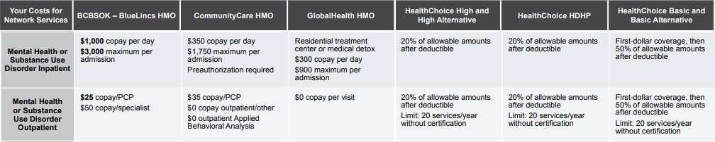

HealthChoice Annual Spend on Mental Health Coverage
- For Mental Health and Substance Abuse services for the active and pre-Medicare population, the plan spends a little over $20 million per year for services provided by facilities and medical professionals. Additionally, the plan spends around $10 million per year on the pharmacy side for behavioral health medications including antidepressants and benzodiazepines.

